This document includes notes on creating a stand alone forest type grid from the TreeMap 2016 data and then combining that w/ LF2016 EVT.

Grids created:

* TM16_FstTyp – forest type grid for CONUS
* Fsttyp_w – forest type grid for western US
* fsttyp_evt200

**CREATING FOREST TYPE STAND ALONE GRID FROM TREE MAP**

Used Lookup to create a grid based on FORTYPCD

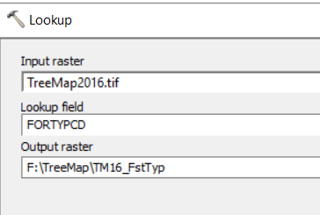

Mask to the west, matched cell size to TM16_FstTyp to retain 30m cell size

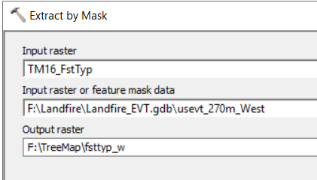

Join attributes

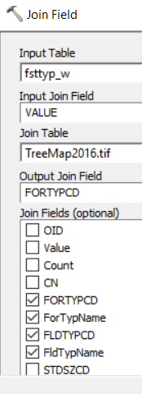

**Combine Fsttyp_w and 2016 EVT w/ mask to clip to west**

Used fsttyp_w as mask and cell size

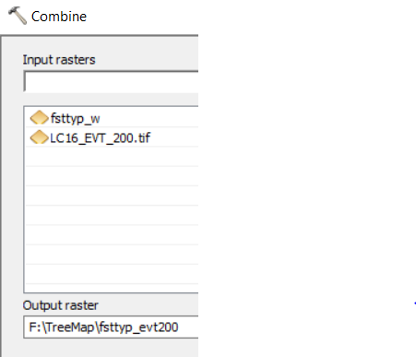

Join attributes

